Willamette Valley Ecoregion Conservation Strategy Supplement:
A Habitat-based Approach to Property Evaluation

Beginning of a writeup…….
For a property to undergo a habitat-based evaluation as a potential conservation site, it must be assessed spatially at multiple scales with the appropriate informative data layers. The state conservation plan calls for “conserving, restoring and reconnecting high value habitats.” Riparian, wetland, oak woodlands, and grassland have been identified as the strategy habitats for the Willamette Valley ecoregion. Robust oak woodland inventory and riparian inventory for the ecoregion exists along with updated habitat maps. Having the data is not enough, however. It must be served spatially through informative maps and geographic information systems (GIS) which landowners and policy makers can easily understand and interpret.
Ecosystem services markets continue to develop and more effort is put into restoring and maintaining biodiversity. A habitat-based approach to conservation strategy identifies centers for biodiversity along with focal habitats. The Willamette Valley National Wildlife Refuge Complex along with state and private refuges provide a foundation for wildlife centers of biodiversity in the Willamette Valley Ecoregion. Establishing connectivity between these centers through areas of strategy habitats, floodplains, and ODFW’s Conservation Opportunity Areas is the focus of a wildlife habitat-based approach to conservation strategy. Figure 1 & 2 are maps showing the spatial relationship between these inputs at a 1:1,000,000 and 1:500,000 scale.
At the 1:100,000 scale (Figure 3), further breakouts of habitat types and local areas of niche habitats can start to be identified. This example map separates the oak inventory data into ‘oak present’ and ‘oak dominant’, and also pulls out ‘ash dominant’ riparian habitat. Oregon ash is a rapidly declining riparian habitat in the valley, and pure oak stands have higher oak restoration value due to lack of Douglas-fir encroachment.
As the scale is zoomed more to 1:50,000 (Figure 4); more of the richness of the informing data sets (in this example: Northwest Habitat Institute’s Oregon White Oak Inventory) comes out, further informing decision making. For this example, species composition has been extrapolated. Other information such as tree size and structural conditions could also be pulled out as a straightforward visual assessment of a stand’s potential for habitat restoration. Figure 5 depicts a site’s evaluation of habitat types, structural conditions, and shrub invasive delineations.
The Willamette Valley Ecoregion continues to face habitat loss and degradation through habitat conversion, invasive species proliferation, fire regime ecological alteration and urban boundary growth. The valley is bisected by the I-5 corridor which contains very few safe wildlife crossings. The complexities of the barriers to wildlife permeability are further compounded by the overwhelming majority of the valley being private land. For wildlife to successfully co-exist in the valley with a rapidly growing human population and infrastructure, conservation efforts must place a weighted emphasis on connectivity of centers for biodiversity and strategy habitats. The focus should be on providing the necessary habitat and structural conditions to sustain and proliferate biodiversity. An incentive-based program would place added value to lands providing connectivity, and lands containing strategy habitats.
Species population modeling and the difference between habitat types and vegetative cover types are confusing to land owners and policy makers. Barriers to wildlife movement and other factors must be taken into account, but a simple rolled-up scale series of maps focusing on the most critical data sets to inform conservation strategy decisions makes the complexity of such decisions much less daunting to agencies, policy makers, and landowners.
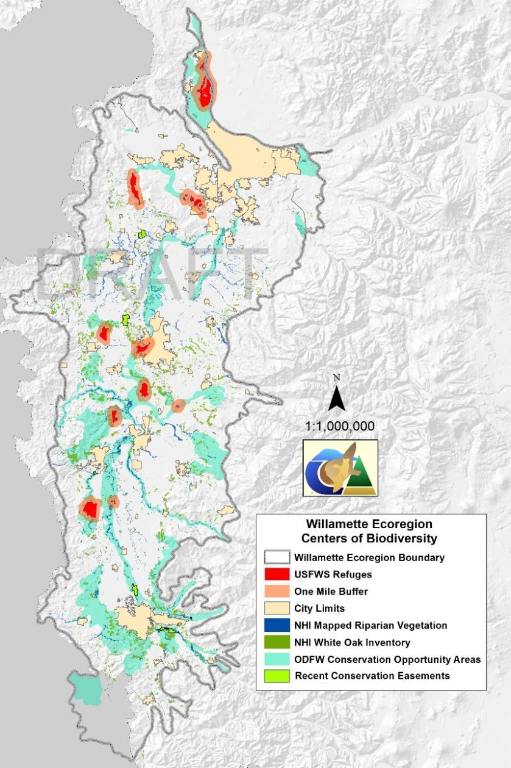
Figure 1: Willamette Ecoregion Centers of Biodiversity 1:1,000,000 scale

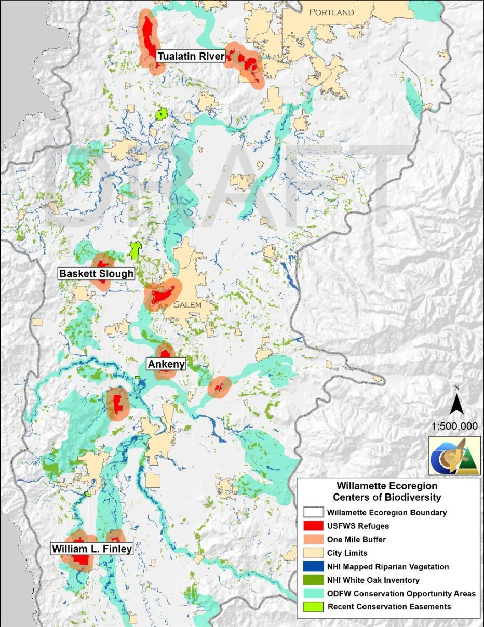
Figure 2: Willamette Ecoregion Centers of Biodiversity 1:500,000 scale
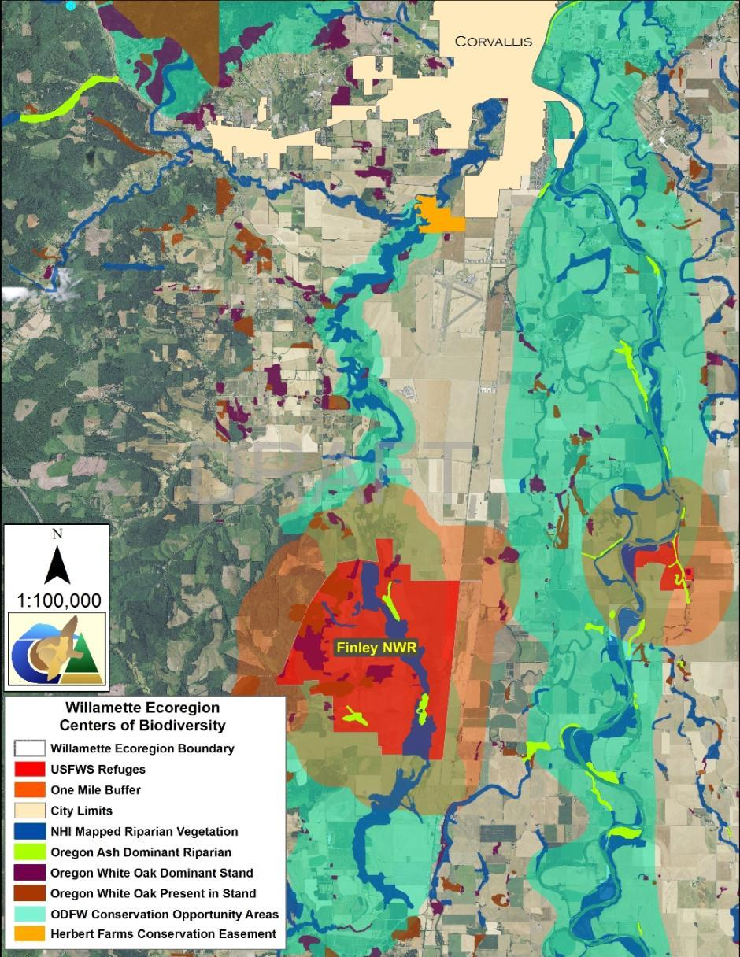
Figure 3: Willamette Ecoregion Centers of Biodiversity 1:100,000 scale
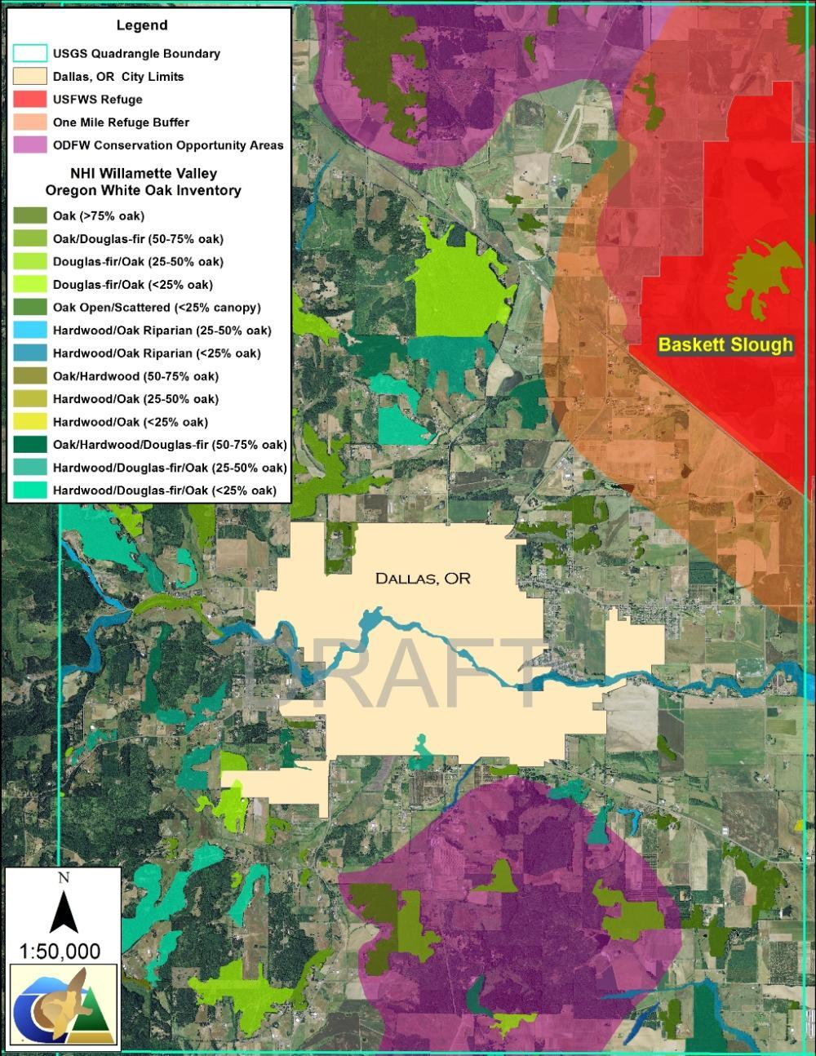
Figure 4: Willamette Ecoregion Centers of Biodiversity 1:50,000 scale
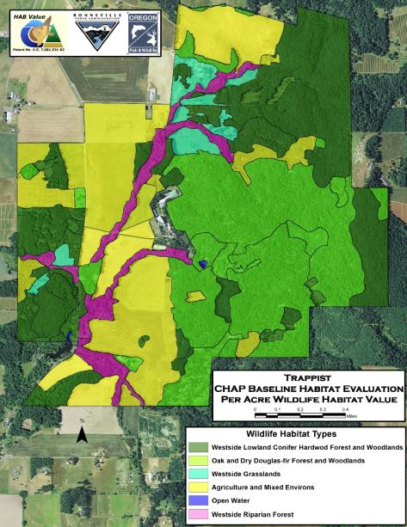
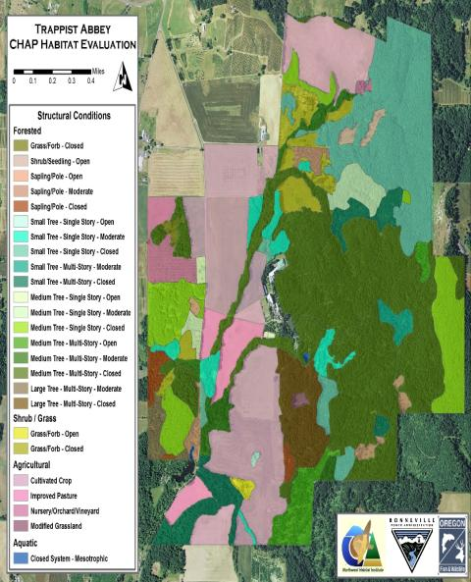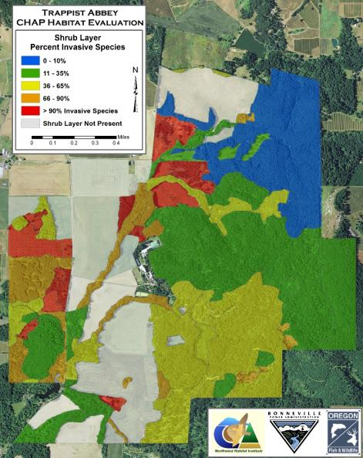
Figure 5: Willamette Project or Site Specific Delineations 1:15,000 scale

